**Modification Log**

|  |  |  |  |
| --- | --- | --- | --- |
| **Version** | **Modification date** | **Author** | **Comments** |
| 1.0 | July 5, 2016 | Evan Situ |  |
| 1.1 | August 28, 2016 | Evan Situ | Split the instructor document |
| 1.2 | August 28, 2016 | Evan Situ | Added Section 5 and 4.1 and 1.4 |
|  |  |  |  |

**Table of Contents**

1. Pre-requisites 2

2. Department Input 2

3. Curriculum Committee Recommendations 5

4. Reports 8

5. Edit Courses and Programs Mapping 11

6. Other Vena Resources 12

# Pre-requisites

1. Access to McMaster Vena <https://vena.io/>
2. Installed Vena Excel add-in
3. Windows operating system
4. Annual Timeline

|  |  |  |  |  |
| --- | --- | --- | --- | --- |
| **Date** | **Task** | **Section Guide** | **Template** | **Task Owner** |
| Early Summer | Archive previous year data | A5 |  | Assoc Dean? |
| Summer | Data copied over to next academic year | A4 |  | Assoc Dean? |
| Summer | Add new courses | A7 |  | Assoc Dean, Department |
| Summer | Changes to programs (mapping b/w courses and programs) | D5 |  | Department |
| Summer | Assign instructors to courses | ? |  | Department |
| Summer | Curriculum mapping, will require consultation and verification with Instructors | D2.3 | Curriculum Mapping Input Template | Department Attributes Committee |
| Summer | Measurement mapping | D2.2 | Measured Indicators Input Template | Department Attributes Committee |
| Aug/Sep | Instructor reviews continuous improvement plan from the previous year | I3.1 | Curriculum Committee Recommendations Report (Previous Year) | Instructor |
| Jan | Instructor enters rubric and their continuous improvement plan for Term 1 | I2 | Rubric Input Template, Course Report | Instructor |
| Dec/Jan | Instructor reviews continuous improvement plan from the previous year | I3.1 | Curriculum Committee Recommendations Report (Previous Year) | Instructor |
| Early May | Instructor enters course reports for Term 2 | I2 | Rubric Input Template, Course Report | Instructor |
| May | Curriculum committees review course reports, generate continuous improvement plan report | I4, D3 | Course Report, Curriculum Committee Recommendations Input Template | Department |
| June | Meeting of continuous improvement committee (external advisors students) |  |  | Department |
| June | Departments plan curriculum revisions |  |  | Department |
| September | Faculty reviews departmental committee reports, writes report |  | ? | Faculty |
| All Year | Add/Remove manage users | A2 |  | Assoc Dean? |
|  | View Historical Data | A6 |  |  |
|  | Assign Users to Process | A3 |  |  |

# Department Input

1. Update Current Year Variable
   * 1. The current year variable drives some of the reports, therefore it is important to update this variable at the beginning of the process
     2. After login to Vena 🡪 Select Task “Update Current Year Variables”🡪Check Out the input template

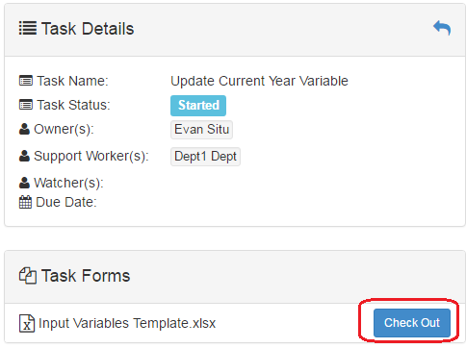

* + 1. Enter the current academic year in the format (yyyy-yyyy) and current year default in the format (yyyy-yyyy Default)🡪 Click “Save Data” under “Vena” Tab and “Check in” the file 🡪Submit the process at Vena front end to finish this task

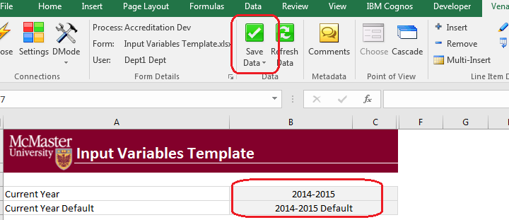

* + 1. After Submit the process, the status should show as “Submitted”

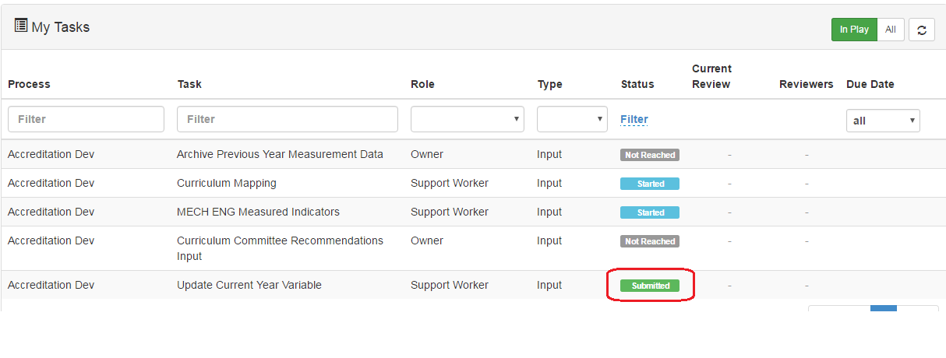

1. Curriculum Mapping Input
   * 1. Check out “Curriculum Mapping”
     2. On the open Excel Sheet 🡪 Select the Program and the Year that you want to enter information
     3. The curriculum mapping is centralized at program level, and it is using the previous year information as starting point of current year, therefore some of the information is prepopulated 🡪 select the level of each course at the indicator level (I – Introduced, D – Developed, A – Applied) 🡪 Click “Save Data” under “Vena” Tab and “Check in” the file

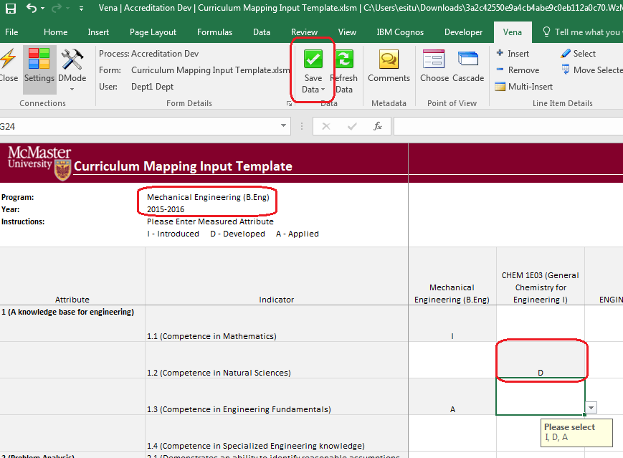

* + 1. Click “Submit” on the Vena front end to finish this task

1. Measured Indicators Input
   * 1. Check out “Measured Indicators”

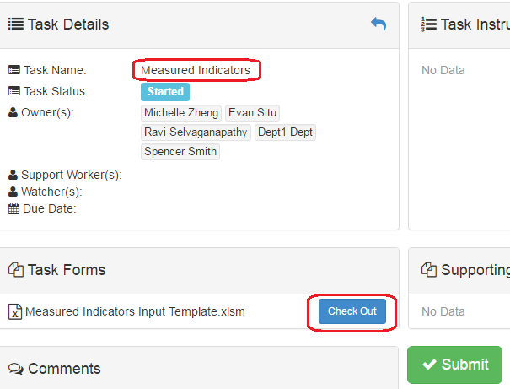

* + 1. On the open Excel Sheet 🡪 Select the Program and the Year that you want to enter information

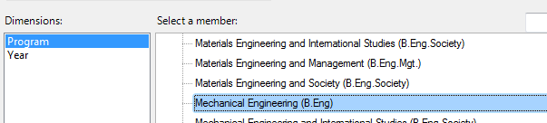

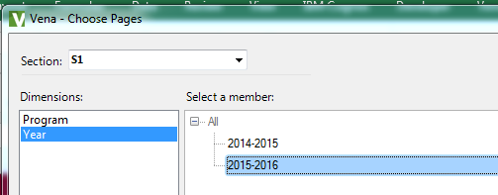

* + 1. The measured indicator map is centralized at program level, and it is using the previous year information as starting point of current year, therefore some of the information is prepopulated 🡪 enter an “M” to the in the intersection of indicator and course to indicator the measuring of the course 🡪 Click “Save Data” under “Vena” Tab and “Check in” the file

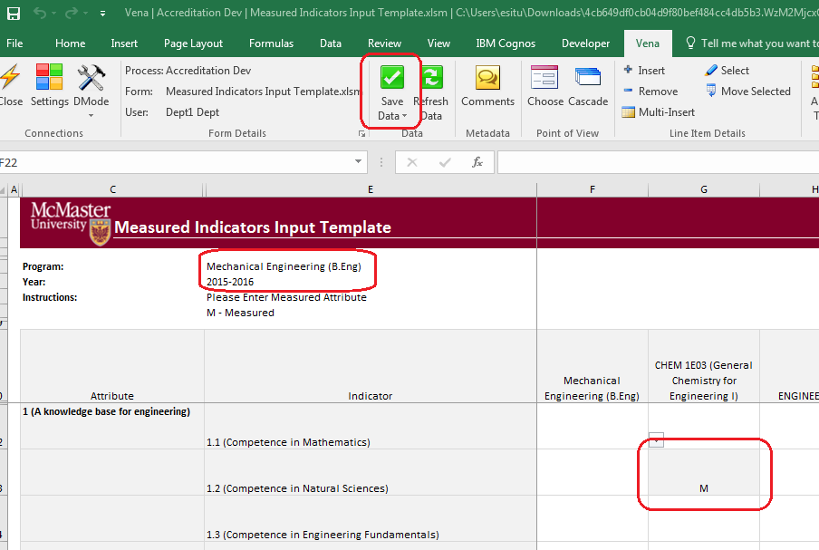

* + 1. Click “Submit” on the Vena front end to finish this task

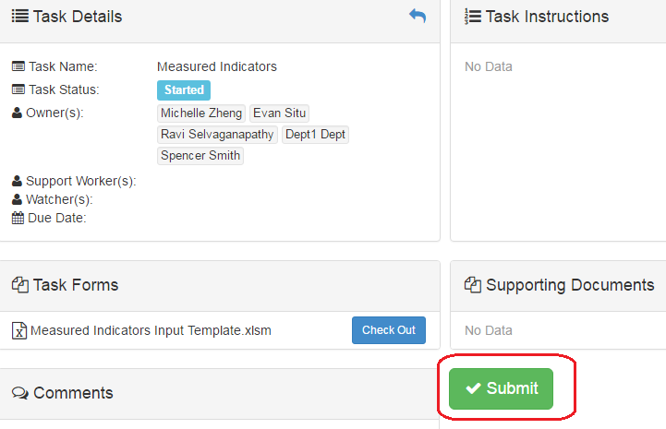

# Curriculum Committee Recommendations

* 1. Check out “Curriculum Committee Recommendations Input Template”

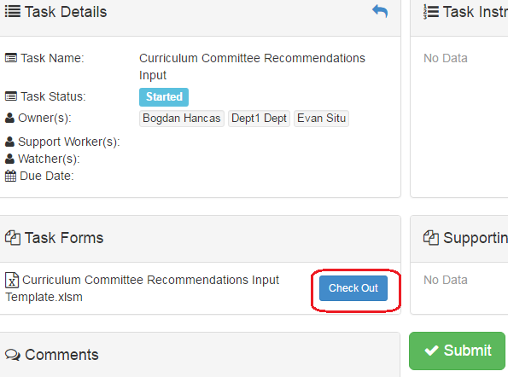

* 1. Once the Excel template open 🡪 select program and year

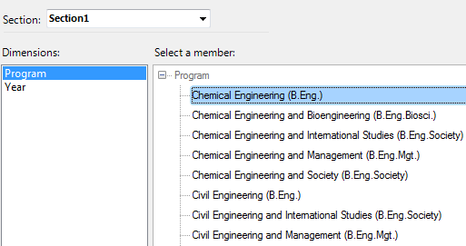

* 1. Enter recommendations to the program and courses

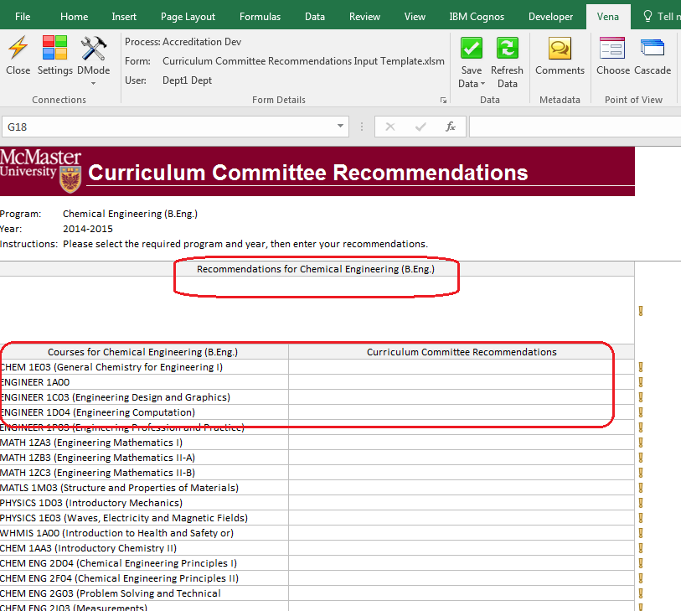

* 1. There is option to attach file to the recommendations (Course and Program level)

Click “Comments” under “Vena” Tab🡪 On the pop-up windows, click “Attach File” to choose the file you want to attach 🡪 click “Add”

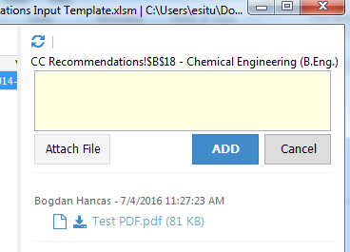

* 1. Click “Save Data” under “Vena” Tab and “Check in” the file🡪 Click “Submit” on the Vena front end to finish this task

# Reports

* 1. Curriculum Committee Recommendations Report
     1. Shows the recommendations from curriculum committee at both course and program level.
     2. If an attachment is included from curriculum committee, it can be viewed by select the program recommendation area🡪Click on “Comments” under “Vena” Tab (see below picture)

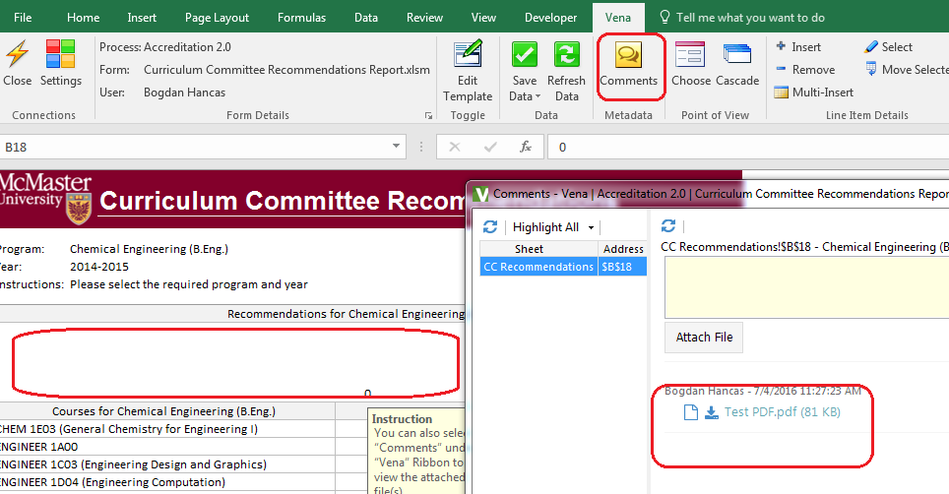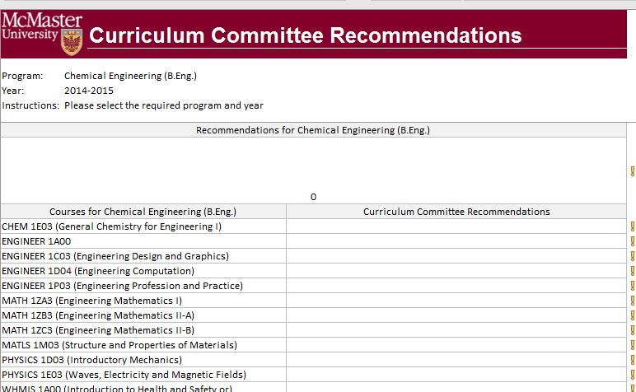

* 1. Attribute Map Report

Indicated the measure level at the attribute level, if different indicator level appears, the highest level will show up A >D>I.

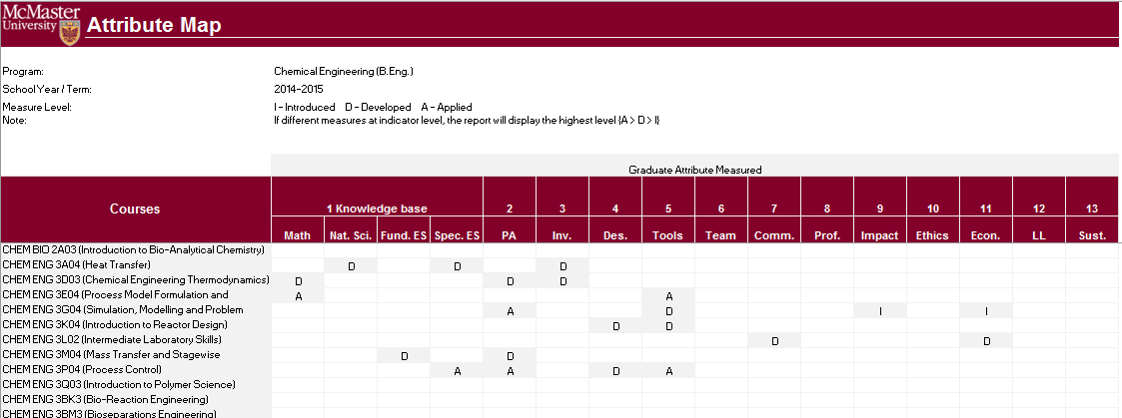

* 1. Attribute Map Summary Report

Similar to the Attribute report, instead showing the actual level (A, D, I), the summary report will only show the “X” to indicate that the specific course is measured at the specific attribute.

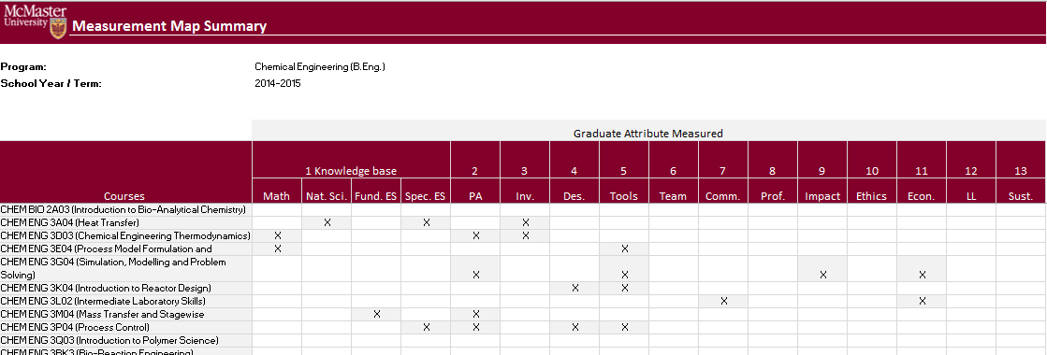

* 1. Indicator Map Report

Indicated the measure level at the indicator level (Lowest level in the hierarchy)

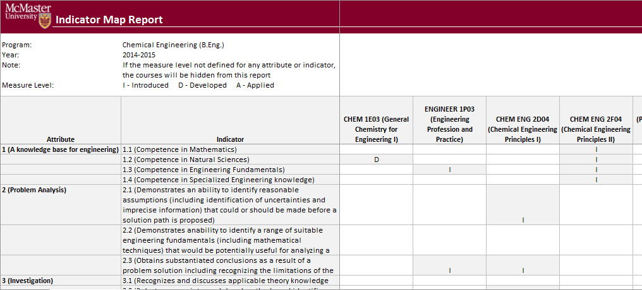

* 1. Historical Course Measurement Report

Shows the historical trend for each course at different level (indicator, attribute and all)

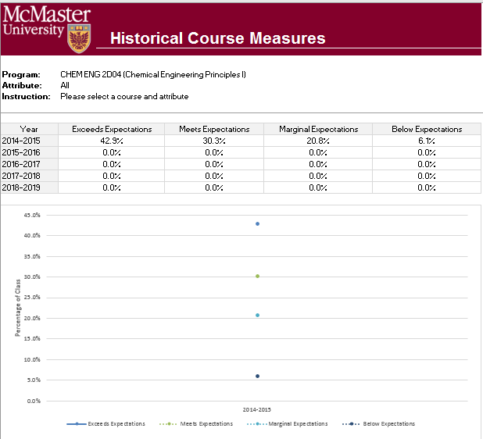

* 1. Historical Program Measurement Report

Shows the historical trend for each course at different level (indicator, attribute and all)

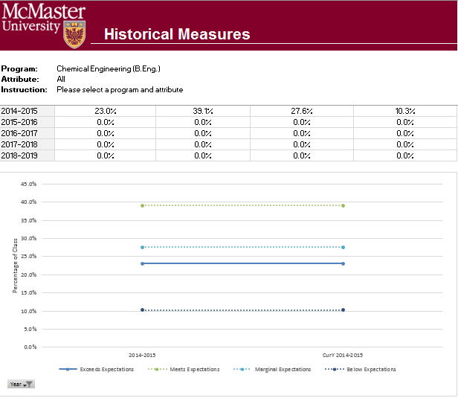

* 1. Course Report

Shows the course outcome and recommendations from curriculum committee, instructors also have the option to enter continuous improvement plan from the course report

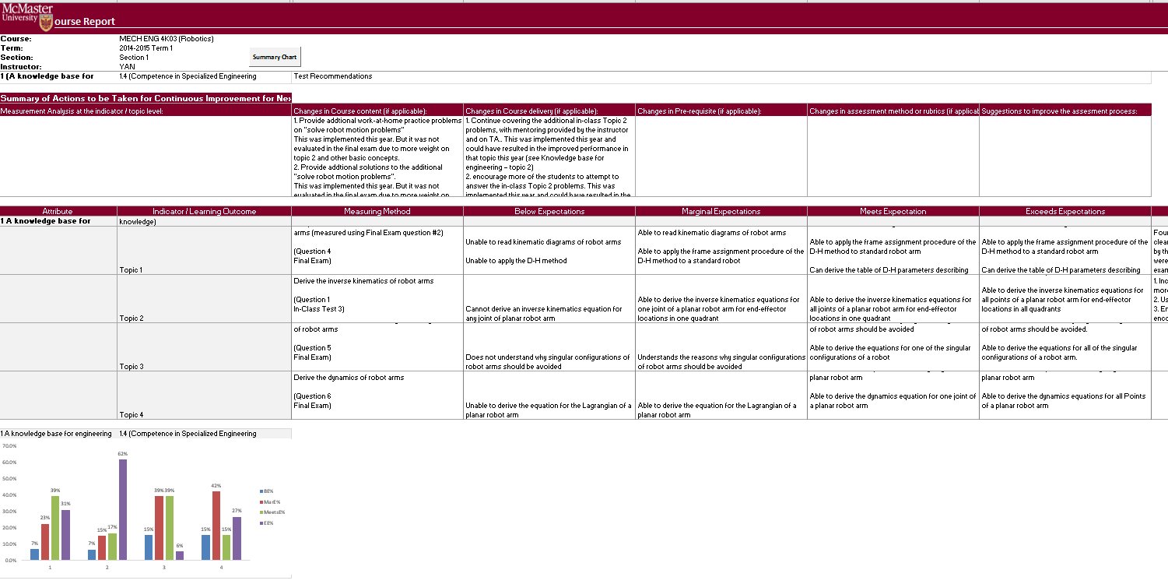

# Edit Courses and Programs Mapping

* 1. Login Vena as Modeler or Admin
  2. Click on “Modeler” at the top navigation bar
  3. Click on “Program” at the left navigation bar
  4. Expand the “Member Name” 🡪Right Click at a course or program you would like to move🡪Click “Cut” 🡪Select destination parent member🡪Right Click then choose “Paste”
  5. The above process can also be done by dragging and dropping the child member to the parent member

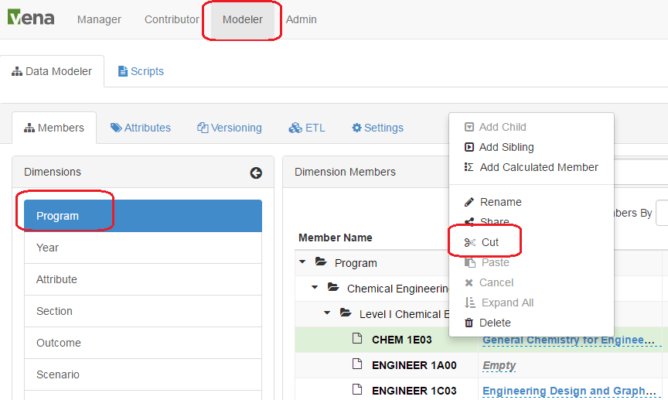

# Other Vena Resources

* 1. For detail documentation, please refer to the precious document.
  2. For Vena training or user manual, please refer to <http://docs.vena.io/>
  3. For other helps please contact:
* Bogdan Hancas: [bhancas@venasolutions.com](mailto:bhancas@venasolutions.com)
* Evan Situ: [esitu@venasolutions.com](mailto:esitu@venasolutions.com)